**Brain MRI Diagnosis and Prediction**

**MRI：**Magnetic Resonance Imaging

**sMRI= structural 3D T1-weighted MRI**

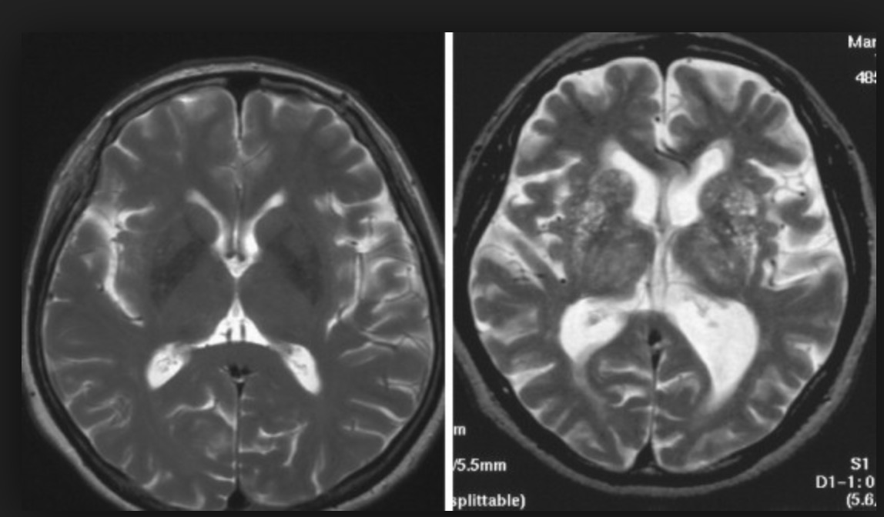

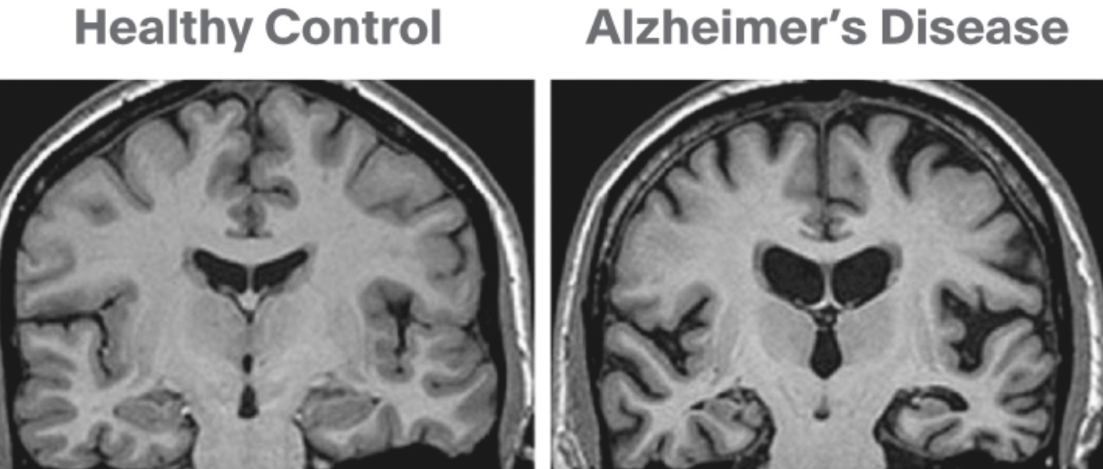

**dMRI=diffusion weighted MRI(stack of slices in blue superimposed on sMRI)**

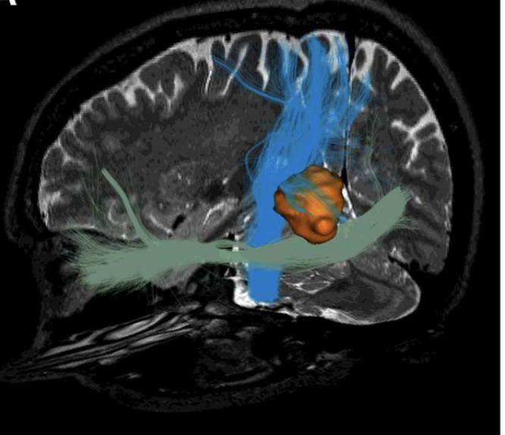

**fMRI= functional BOLD MRI(in red)**

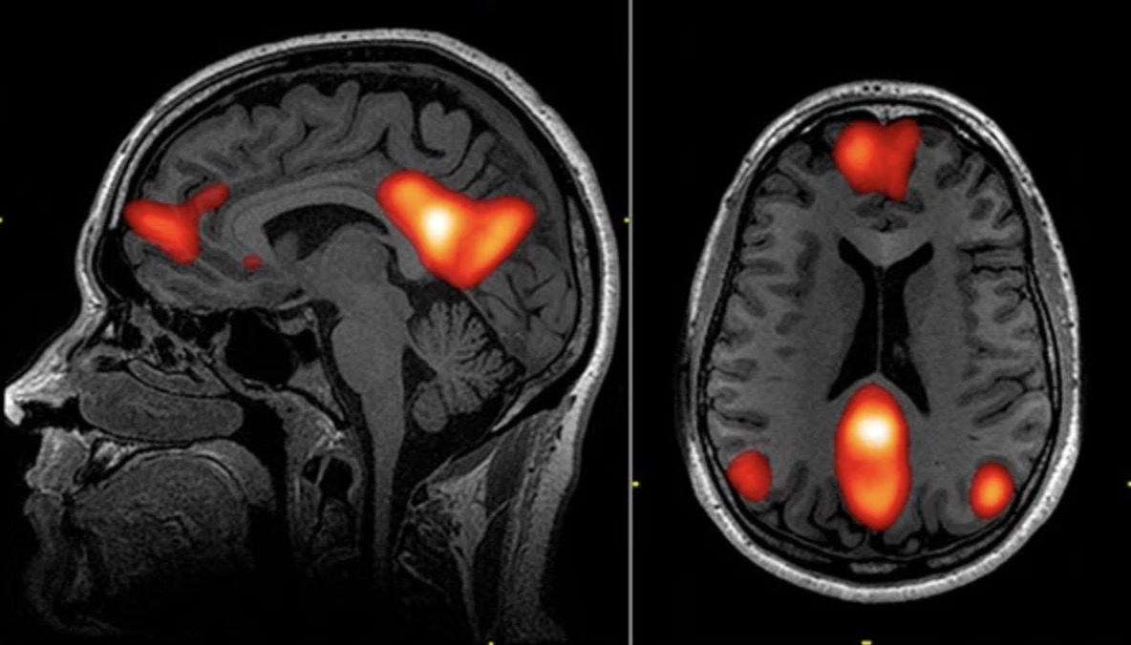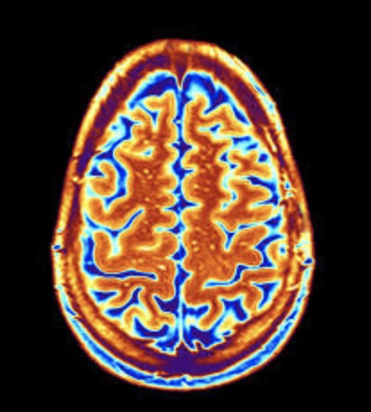**Autism**

**Brain MRI Main research area by using deep learning method**

Brain extraction

Functional connectomes

Structural connectomes

Brain age

*Alzheimer and Disease Prediction(65, 85, 4, tao(cortex,white matter), abeta(speckle))*

Vascular lesions

Identification of MRI contrast

Meningioma

Glioma

Multiple sclerosis

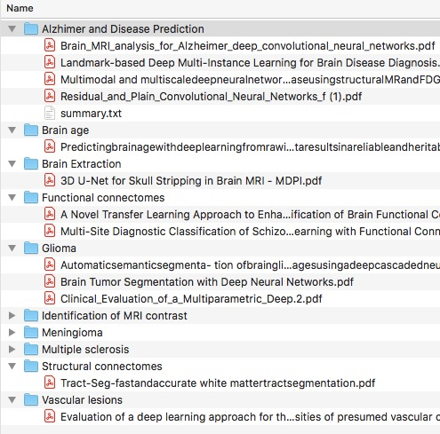

**Brain MRI Medical image data set**

**OpenNeuro**

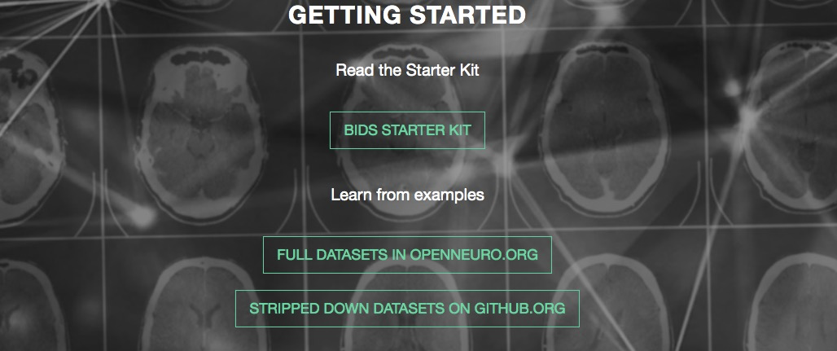

https://openneuro.org

An open platform for sharing neuroimaging data under the public domain license. Contains brain images from 168 studies (4,718 participants) with various imaging modalities and acquisition protocols.

**UK Biobank**

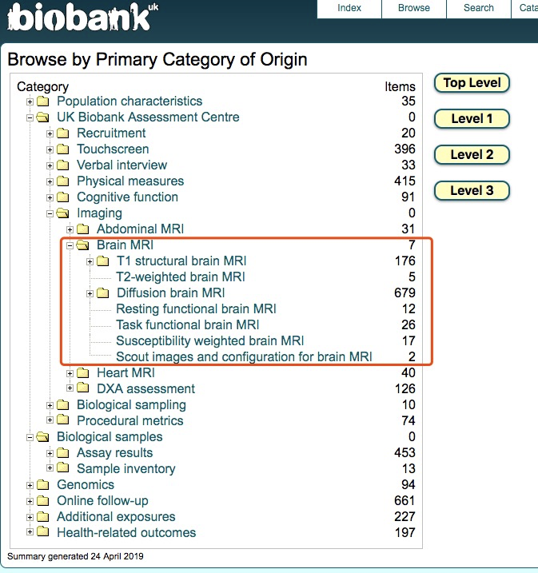

http://www.ukbiobank.ac.uk/

Health data from half a million participants. Contains MRI images from 15,000 participants, aiming to reach 100,000.

**TCIA**

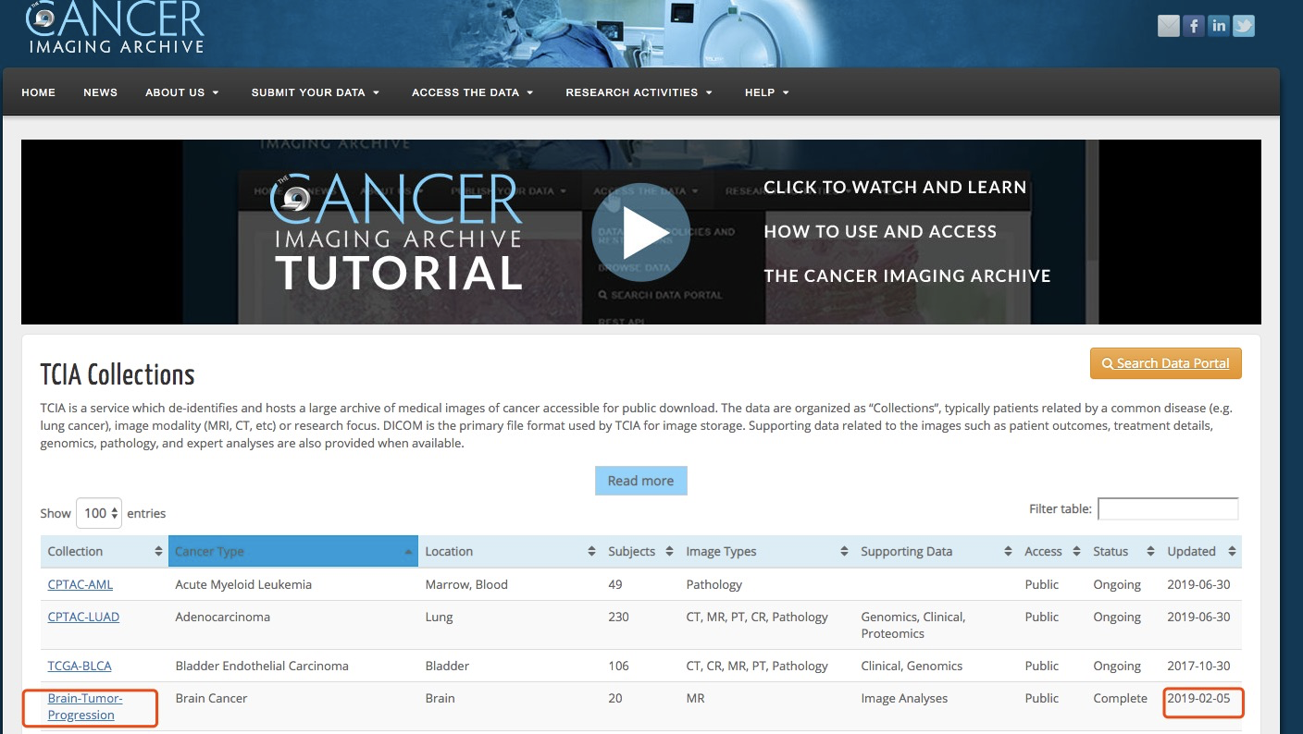

http://www.cancerimagingarchive.net

The cancer imaging archive hosts a large archive of medical images of cancer accessible for public download. Currently contains images from 14,355 patients across 77 collections.

**ABIDE**

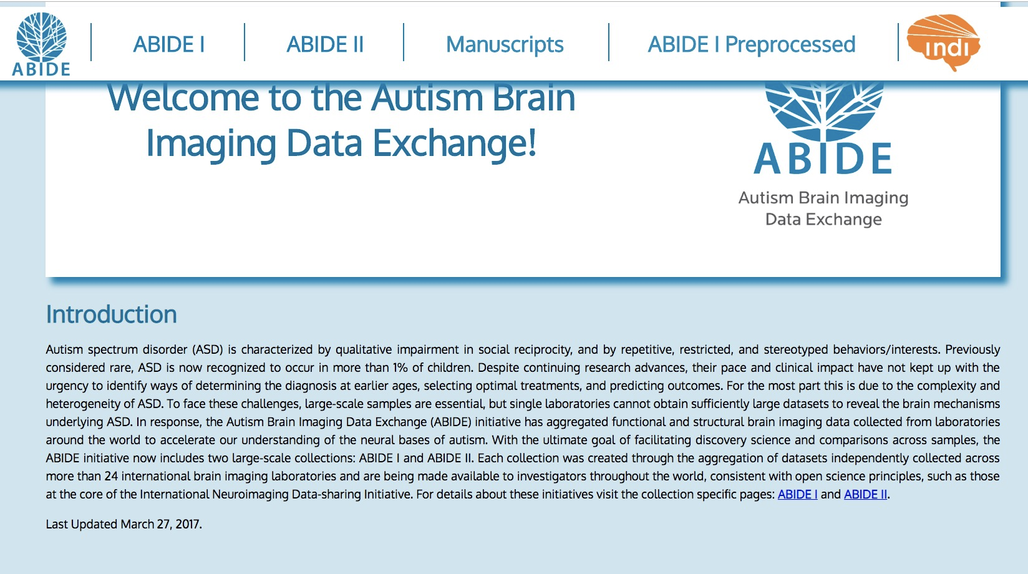

http://fcon_1000.projects.nitrc.org/indi/abide

The autism brain imaging data exchange. Contains 1114 datasets from 521 individuals with Autism Spectrum Disorder and 593 controls.

**ADNI**

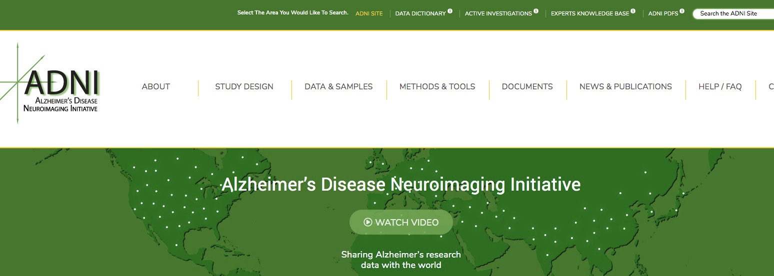

http://adni.loni.usc.edu/

The Alzheimer’s disease neuroimaging initiative. Contains image data from almost 2000 participants (controls, early MCI, MCI, late MCI, AD)